DIS-INDO-Borneo-Dayak-Shaman Mask

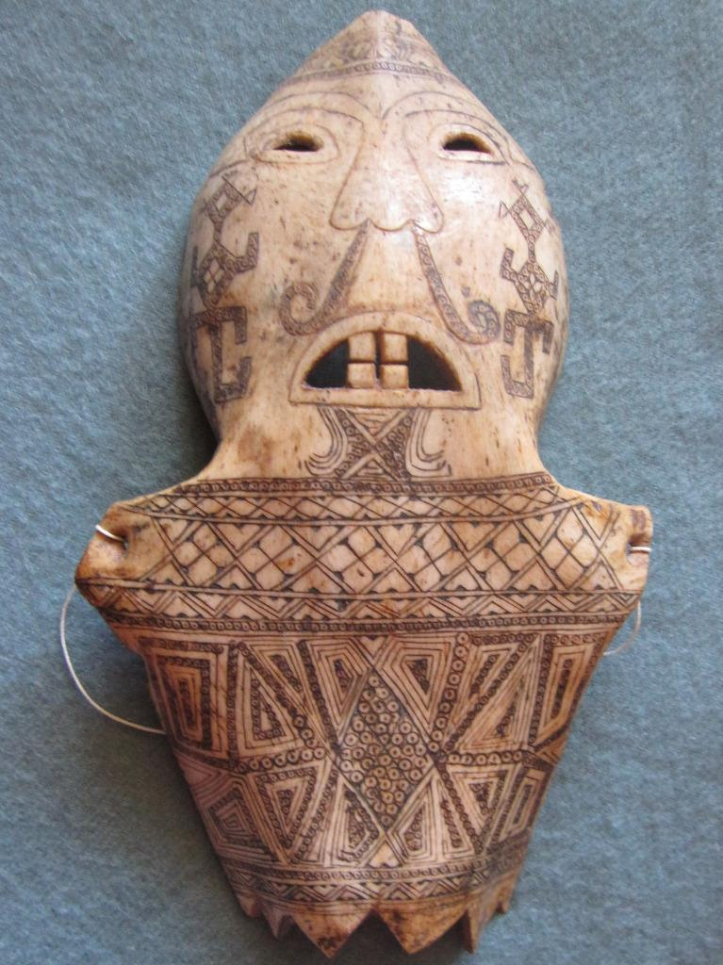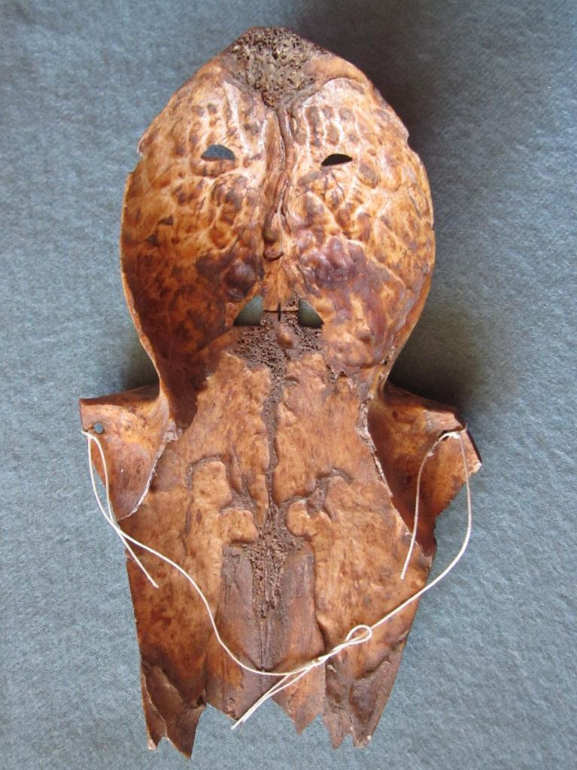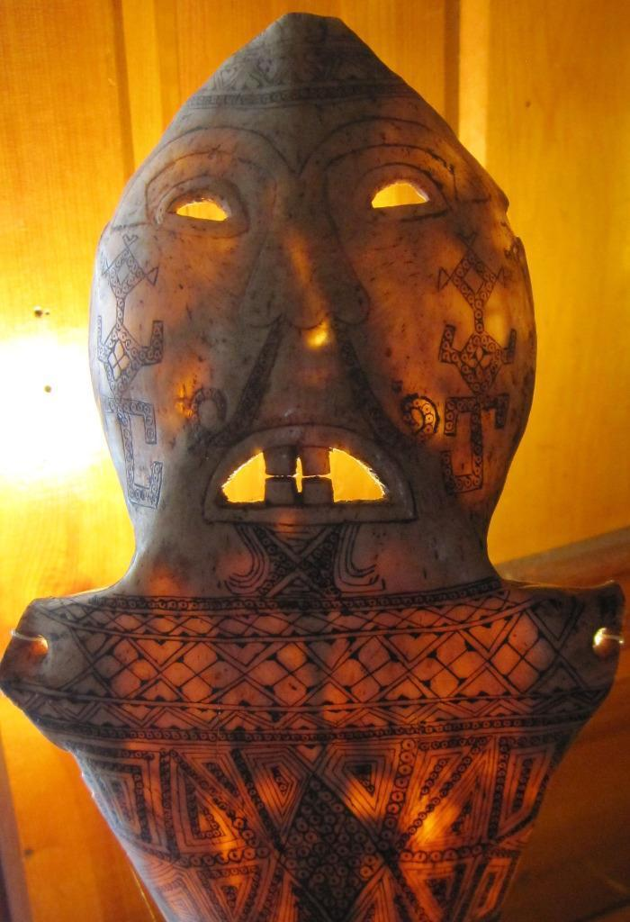

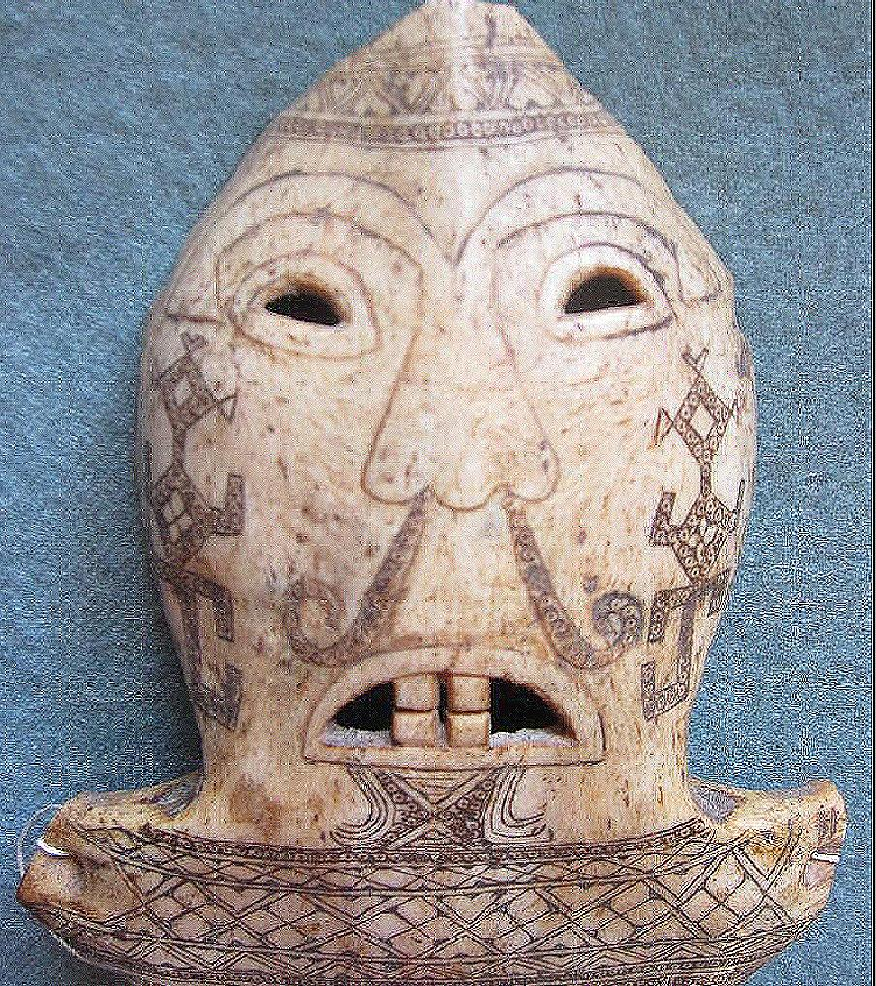

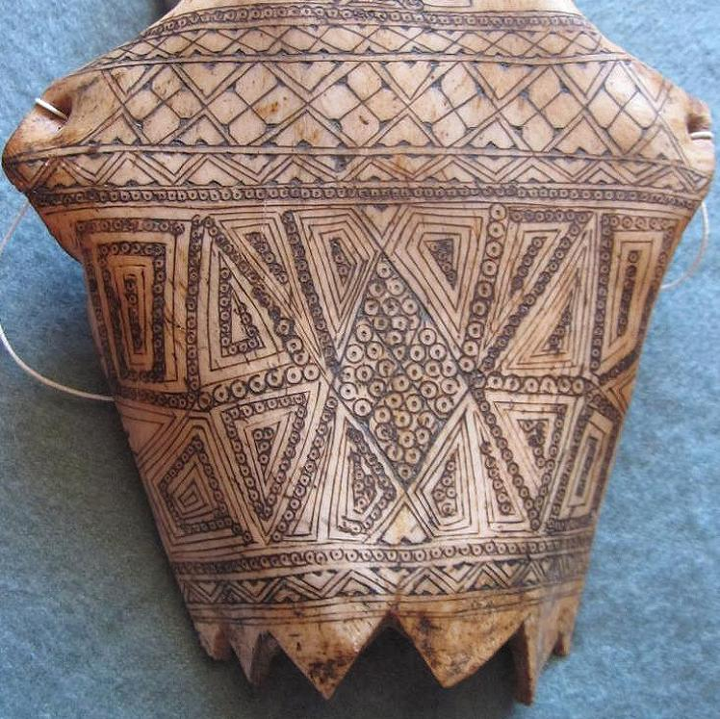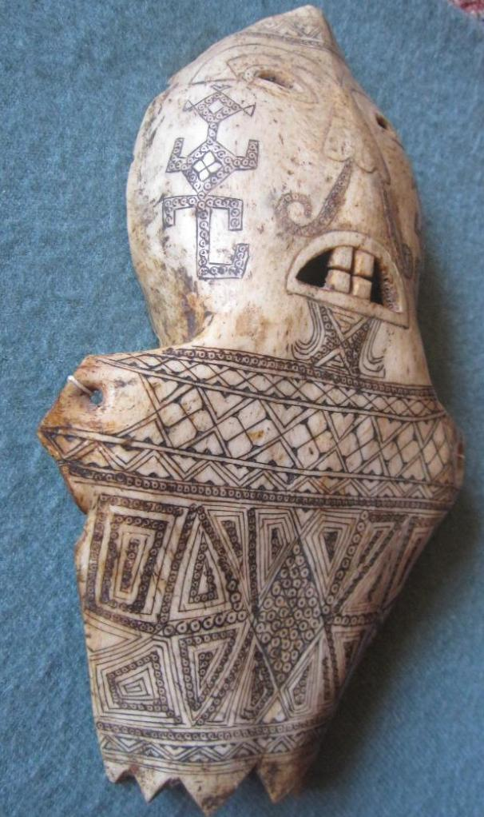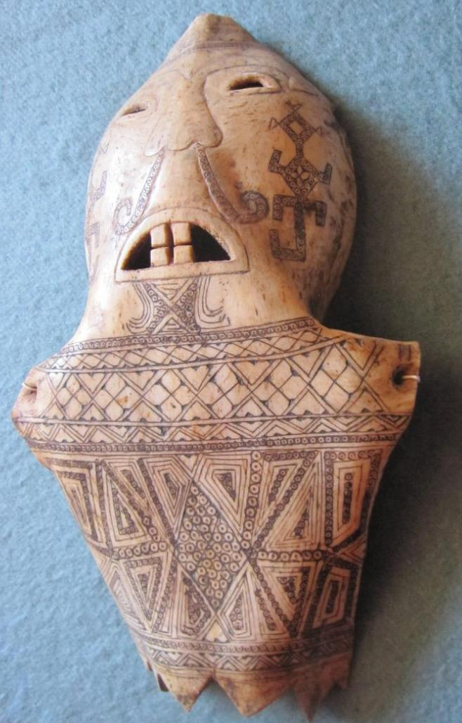

### Delivery package 1 of 1    FAST 'N FREE

Estimated delivery Wednesday, Mar 16, 2016 - Saturday, Mar 19, 2016

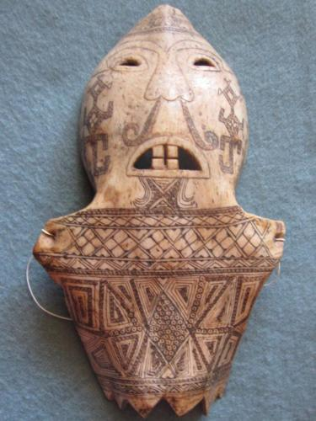

#### [20C Batak water buffalo bone spirit shaman MASK East BORNEO Indonesia tattooed](http://www.ebay.com/itm/262292346638)

|  |  |
| --- | --- |
| Item price | $215.00 |
| Quantity | 1 |
| Item number | 262292346638 |
| Shipping service | USPS Priority Mail Medium Flat Rate Box |

## Shipping address

Ralph J Coffman Jr

149 Atlantic Ave

Swampscott MA 01907-2427

United States

## Order total

|  |  |
| --- | --- |
| Subtotal | $215.00 |
| Shipping | Free |

**Total**

$215.00

Order placed on

Monday, Mar 14, 2016

Payment method

PayPal

Payment date

Monday, Mar 14, 2016